LOCATION : NATIONWIDE
DATE : 23.02.2018

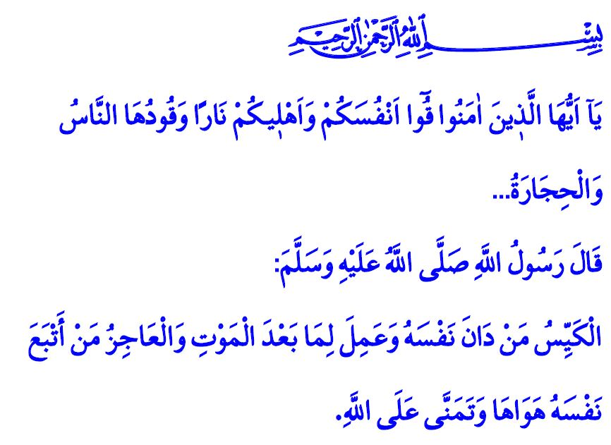
ADDICTION IS A TRAP
Jumu’ah Mubarak, Dear Brothers and Sisters!
Our Lord Almighty enjoins in the verse I have recited: “O you who believe! Ward off from yourselves and your families a Fire (Hell) whose fuel is men and stones…”
Our Prophet (s.a.w.) said in the hadith I have read: “The clever person is the one who subjugates his soul, and works for what is after death. And the incapable is the one who follows his desires and merely hopes in Allah.”
Brothers and Sisters!
Humans are the noblest of all creation; they are the most valuable and most honorable member of the world of creatures. Islam was sent to the humans for them to live a life fitting to this value and to attain happiness in this life and in the Hereafter. The goal of our supreme religion is to protect the life, property, mind, chastity and faith of humans from all evil, sedition and mischief. Therefore, Islam fights against anything that threatens the life and property of humans, weakens their mind and reason, harms their honor and descendants and takes away their freedom of religion and belief. Islam forbids all harmful habits and addictions that disturb the peace of the individuals, family, and society.
Honorable Believers!
The Holy Qur’an insistently repeats that the life in this world is a trial and those who want to be successful in this trial must not be captured by their nafs (desires). A person who pursues temporary whims, endless wishes and desires ends in defeat. Any addiction that makes us forget the importance, value and seriousness of this short life is a trap. Bad habits that waste our time, money and health are a threat to our future.
Dear Muslims!
While the Holy Qur’an repeatedly asks us “Will you not reason?”, how can a person whose brain is clouded by alcohol and drugs think? While our Lord warns us with the words “How seldom are you grateful!”, how can a person who spends hours in front of a screen detached from life see the blessings around him/her and give thanks to Allah? While our Prophet (s.a.w) says “Sufficient sin for a man is that he neglects those he should provide for.”, how can a person who spends the night on gambling and computer games take care of his/her family?
Brothers and Sisters!
Addiction breaks down families, wastes our national wealth and shakes our spirituality to its foundations. What a shame for a human who is created with the highest qualities to leave this world without using these qualities for the benefit of the society and the ummah! Our children, unfortunately, start bad habits through imitation, curiosity and temptation by their friends. Lacking the necessary care and support from their families, young people feel lonely and without love, and this makes it easy for them to fall into the hands of wicked criminals. It is our duty to guide them, follow their agendas, and meet their spiritual needs as well as their material needs. Our beloved Prophet (s.a.w.) reminds us this important task by saying “Your children has a right upon you.”
Honorable Brothers and Sisters!
Our Beloved Prophet said: “There are two blessings which many people lose: Health and free time for doing good.” We should appreciate these two blessings that we notice when we get sick or busy. Let us keenly avoid and advise people to avoid smoking, alcohol and all kinds of drugs which are the biggest enemies of the health of our bodies and souls. Let us be alert about the internet addiction that swallows our time like a black hole and consumes our days by preventing us from taking the time to do good things. Let us learn and teach how to use the technological possibilities that Allah has bestowed us in a clever and conscious manner. Let us not forget that good habits, virtues and morality are acquired within the family; and that our youth can only stay away from addiction with our care and support.
Honorable Believers!
It is our duty to keep our eyes open for the addictions that poison our children and the young while entertaining them such as smoking, alcohol, drugs, gambling, internet, computers and smartphones. Our Lord warns us in this matter by calling attention to the end of a bad course of events: “Yet they were succeeded by generations (of people) who lost all (thought of) prayer and followed (but) their own lusts…”
Let us not forget that our children are our future and our descendants are entrusted to us. For healthy, educated and conscious generations, let us equip the apples of our eyes, our children, with our religion, culture and identity so that they can protect themselves from all kinds of evil.
I would like to conclude this khutbah with the following hadith of our Prophet (s.a.w.): “The feet of the son of Adam shall not move from before his Lord on the Day of Judgement, until he is asked about five things: about his life and what he did with it, about his youth and what he wore it out in, about his wealth and how he earned it and spent it upon, and what he did with what he knew.”

Tahrim, 66/6.
Tirmidhi, Sifat al-Qiyamah, 25.
Abu Dawud, Zakat, 45.
Muslim, Siyam, 183.
Bukhari, Riqaq, 1.
Maryam, 19/59.
Tirmidhi, Sifat al-Qiyamah, 1. Issued by: General Directorate of Religious Services

